**1. Develop a Simple Android Application displaying “Hello World”:**

**Project Name: HelloWorld**

**activity_main.xml:**

<?xml version="1.0" encoding="utf-8"?>  
<LinearLayout xmlns:android="http://schemas.android.com/apk/res/android"  
 android:layout_width="match_parent"  
 android:layout_height="match_parent"  
 android:orientation="vertical"  
 android:gravity="center">  
 <TextView  
 android:layout_width="wrap_content"  
 android:layout_height="wrap_content"  
 android:text="Hello World!"  
 android:textSize="24sp"  
 android:textColor="#000000"/>  
</LinearLayout>

**MainActivity.java:**

package com.example.app1;

import android.os.Bundle;

import androidx.appcompat.app.AppCompatActivity;

public class MainActivity extends AppCompatActivity {

@Override

protected void onCreate(Bundle savedInstanceState)

super.onCreate(savedInstanceState);

setContentView(R.layout.activity_main);

}

}

**Output:**

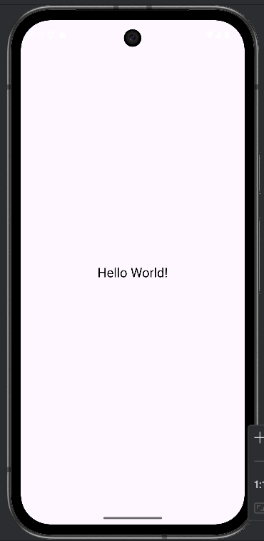

**2. Develop an Android Application using “Button” Component:**

**Project Name: Buttons**

**activity_main.xml:**

<?xml version="1.0" encoding="utf-8"?>

<LinearLayout xmlns:android="http://schemas.android.com/apk/res/android"

android:layout_width="match_parent"

android:layout_height="match_parent"

android:orientation="vertical"

android:padding="16dp">

<!-- First Button -->

<Button

android:id="@+id/button1"

android:layout_width="wrap_content"

android:layout_height="wrap_content"

android:text="Button 1"

android:padding="8dp" />

<!-- Second Button -->

<Button

android:id="@+id/button2"

android:layout_width="wrap_content"

android:layout_height="wrap_content"

android:text="Button 2"

android:padding="8dp" />

</LinearLayout>

**MainActivity.java:**

package com.example.app2;

import android.os.Bundle;

import androidx.appcompat.app.AppCompatActivity;

public class MainActivity extends AppCompatActivity {

@Override

protected void onCreate(Bundle savedInstanceState) {

super.onCreate(savedInstanceState);

setContentView(R.layout.activity_main);

}

}

**Output:**

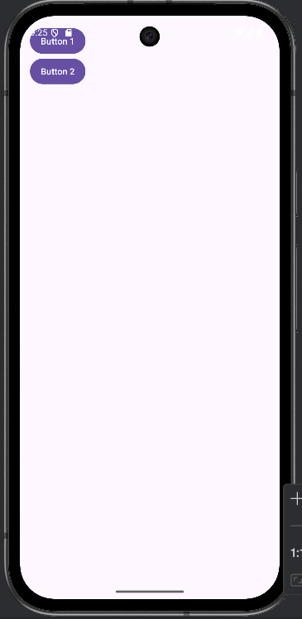

**3. Develop an Android Application by implementing “Vertical Linear Layout”:**

**Project Name: VerticalLinearLayout**

**activity_main.xml:**

<?xml version="1.0" encoding="utf-8"?>

<LinearLayout xmlns:android="http://schemas.android.com/apk/res/android"

android:layout_width="match_parent"

android:layout_height="match_parent"

android:orientation="vertical"

android:padding="16dp">

<TextView

android:id="@+id/textview1"

android:layout_width="wrap_content"

android:layout_height="wrap_content"

android:text="Hello, World!"

android:textSize="20sp"

android:padding="8dp" />

<TextView

android:id="@+id/textview2"

android:layout_width="wrap_content"

android:layout_height="wrap_content"

android:text="Welcome to Android Development!"

android:textSize="20sp"

android:padding="8dp" />

<!-- First Button -->

<Button

android:id="@+id/button1"

android:layout_width="wrap_content"

android:layout_height="wrap_content"

android:text="Button 1"

android:padding="8dp" />

<!-- Second Button -->

<Button

android:id="@+id/button2"

android:layout_width="wrap_content"

android:layout_height="wrap_content"

android:text="Button 2"

android:padding="8dp" />

</LinearLayout>

MainActivity.java:

package com.example.app3;

import android.os.Bundle;

import androidx.appcompat.app.AppCompatActivity;

public class MainActivity extends AppCompatActivity {

@Override

protected void onCreate(Bundle savedInstanceState) {

super.onCreate(savedInstanceState);

setContentView(R.layout.activity_main); **// Set the content view to the XML layout with the vertical LinearLayout**

}

}

**Output:**

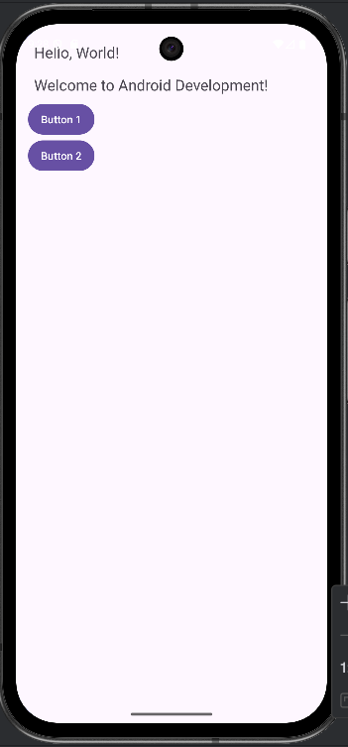

**4. Develop an Android Application by implementing “Horizontal Linear Layout”:**

**Project Name: HorizontalLinearLayout**

**activity_main.xml:**

<?xml version="1.0" encoding="utf-8"?>

<LinearLayout xmlns:android="http://schemas.android.com/apk/res/android"

android:layout_width="match_parent"

android:layout_height="match_parent"

android:orientation="horizontal"

android:padding="16dp">

<TextView

android:id="@+id/textview1"

android:layout_width="wrap_content"

android:layout_height="wrap_content"

android:text="Hello"

android:textSize="20sp"

android:padding="8dp" />

<TextView

android:id="@+id/textview2"

android:layout_width="wrap_content"

android:layout_height="wrap_content"

android:text="World!"

android:textSize="20sp"

android:padding="8dp" />

<!-- First Button -->

<Button

android:id="@+id/button1"

android:layout_width="wrap_content"

android:layout_height="wrap_content"

android:text="Button 1"

android:padding="8dp" />

<!-- Second Button -->

<Button

android:id="@+id/button2"

android:layout_width="wrap_content"

android:layout_height="wrap_content"

android:text="Button 2"

android:padding="8dp" />

</LinearLayout>

**MainActivity.java:**

package com.example.app4;

import android.os.Bundle;

import androidx.appcompat.app.AppCompatActivity;

public class MainActivity extends AppCompatActivity {

@Override

protected void onCreate(Bundle savedInstanceState) {

super.onCreate(savedInstanceState);

setContentView(R.layout.activity_main); **// Set the content view to the XML layout with the horizontal LinearLayout**

}

}

**Output:**

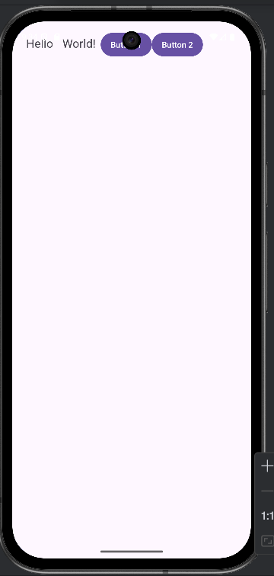

**ImageView:** It is used to display images in an app. It allows you to show pictures, icons, or other graphics in your application's interface.

**5. Develop an Android Application using “ImageView” Component:**

**Project Name: ImageViews**

**activity_main.xml:**

<?xml version="1.0" encoding="utf-8"?>  
<LinearLayout xmlns:android="http://schemas.android.com/apk/res/android"  
 android:layout_width="match_parent"  
 android:layout_height="match_parent"  
 android:orientation="vertical"  
 android:gravity="center"  
 android:padding="16dp">  
 <!-- ImageView -->  
 <ImageView  
 android:id="@+id/imageView"  
 android:layout_width="wrap_content"  
 android:layout_height="wrap_content"  
 android:src="@drawable/happy_face"  
 android:contentDescription="Happy face" />  
</LinearLayout>

**MainActivity.java:**

package com.example.app5;

import android.os.Bundle;

import androidx.appcompat.app.AppCompatActivity;

public class MainActivity extends AppCompatActivity {

@Override

protected void onCreate(Bundle savedInstanceState) {

super.onCreate(savedInstanceState);

setContentView(R.layout.activity_main);

}

}

**Output:**

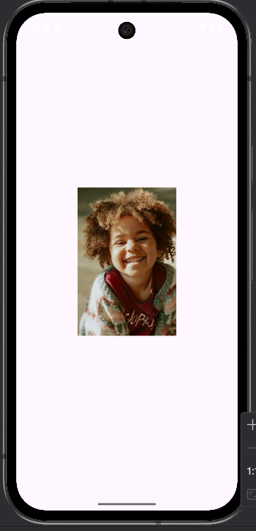

**Edit Text:** It is a user interface component that allows users to input and edit text. It’s similar to a text box in other programming environments.

**6. Develop an Android Application using “EditText” Component:**

**Project Name: EditTexts**

**activity_main.xml:**

<?xml version="1.0" encoding="utf-8"?>

<LinearLayout xmlns:android="http://schemas.android.com/apk/res/android"

android:layout_width="match_parent"

android:layout_height="match_parent"

android:orientation="vertical"

android:padding="16dp">

<!-- EditText -->

<EditText

android:id="@+id/editText"

android:layout_width="match_parent"

android:layout_height="wrap_content"

android:hint="Enter text here"

android:inputType="text" />

</LinearLayout>

**MainActivity.java:**

package com.example.app6;

import android.os.Bundle;

import androidx.appcompat.app.AppCompatActivity;

public class MainActivity extends AppCompatActivity {

@Override

protected void onCreate(Bundle savedInstanceState) {

super.onCreate(savedInstanceState);

setContentView(R.layout.activity_main);

}

}

**Output:**

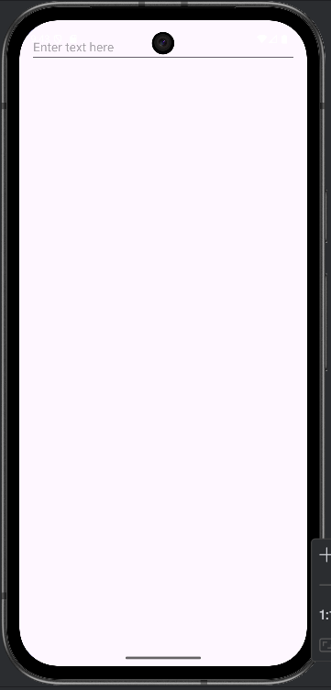

**Radio Button:** It is commonly used UI component in Android that allow users to select one option from a set of mutually exclusive choices.

**7. Develop an Android Application using “Radio Button” Component:**

**Project Name: RadioButtonExample**

**activity_main.xml:**

<?xml version="1.0" encoding="utf-8"?>

<LinearLayout xmlns:android="http://schemas.android.com/apk/res/android"

android:layout_width="match_parent"

android:layout_height="match_parent"

android:orientation="vertical"

android:padding="16dp">

<!-- RadioGroup to group RadioButtons -->

<RadioGroup

android:id="@+id/radioGroup"

android:layout_width="wrap_content"

android:layout_height="wrap_content">

<!-- RadioButton options -->

<RadioButton

android:id="@+id/radioButton1"

android:layout_width="wrap_content"

android:layout_height="wrap_content"

android:text="Option 1" />

<RadioButton

android:id="@+id/radioButton2"

android:layout_width="wrap_content"

android:layout_height="wrap_content"

android:text="Option 2" />

<RadioButton

android:id="@+id/radioButton3"

android:layout_width="wrap_content"

android:layout_height="wrap_content"

android:text="Option 3" />

</RadioGroup>

</LinearLayout>

**MainActivity.java:**

package com.example.app7;

import android.os.Bundle;

import androidx.appcompat.app.AppCompatActivity;

public class MainActivity extends AppCompatActivity {

@Override

protected void onCreate(Bundle savedInstanceState) {

super.onCreate(savedInstanceState);

setContentView(R.layout.activity_main);

**// No implementation action needed**

}

}

**Output:**

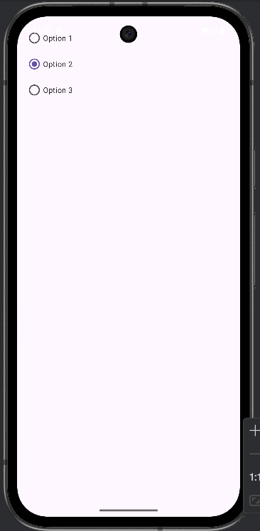

**TextView: It is used to display text on the screen. It's often used to show labels, instructions, or any other text content in an app.**

**8. Develop an Android Application using “TextView” Component:**

**Project Name: TextViews**

**activity_main.xml:**

**<?xml version="1.0" encoding="utf-8"?>**

**<LinearLayout xmlns:android="http://schemas.android.com/apk/res/android"**

**android:layout_width="match_parent"**

**android:layout_height="match_parent"**

**android:orientation="vertical"**

**android:gravity="center"**

**android:padding="16dp">**

**<!-- TextView -->**

**<TextView**

**android:id="@+id/textView"**

**android:layout_width="wrap_content"**

**android:layout_height="wrap_content"**

**android:text="Hello, World!"**

**android:textSize="24sp"**

**android:padding="8dp" />**

**</LinearLayout>**

**MainActivity.java:**

**package com.example.app8;**

**import android.os.Bundle;**

**import android.widget.TextView;**

**import androidx.appcompat.app.AppCompatActivity;**

**public class MainActivity extends AppCompatActivity {**

**@Override**

**protected void onCreate(Bundle savedInstanceState) {**

**super.onCreate(savedInstanceState);**

**setContentView(R.layout.activity_main);**

**// Find the TextView by its ID**

TextView textView = findViewById(R.id.textView);

textView.setText("Welcome to Android Development!"); **// Change the text programmatically**

}

}

**Output:**

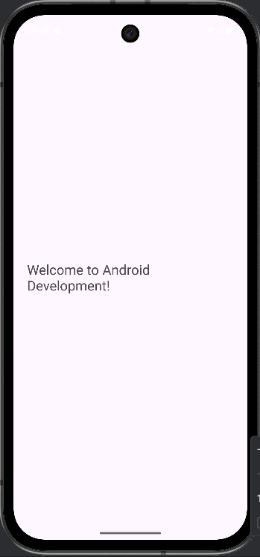

**Checkbox:** It is an UI Element which allows users to select or deselect an option. It is typically used when you want to let users select multiple options from a set. When checked, it returns true; when unchecked, it returns false.

**9. Develop an Android Application using “CheckBox” Component:**

**Project Name: CheckBoxExample**

**activity_main.xml:**

<?xml version="1.0" encoding="utf-8"?>

<LinearLayout xmlns:android="http://schemas.android.com/apk/res/android"

android:layout_width="match_parent"

android:layout_height="match_parent"

android:orientation="vertical"

android:padding="16dp">

<!-- Checkbox options -->

<CheckBox

android:id="@+id/checkBoxJava"

android:layout_width="wrap_content"

android:layout_height="wrap_content"

android:text="Java" />

<CheckBox

android:id="@+id/checkBoxML"

android:layout_width="wrap_content"

android:layout_height="wrap_content"

android:text="ML Using Python" />

<CheckBox

android:id="@+id/checkBoxAWS"

android:layout_width="wrap_content"

android:layout_height="wrap_content"

android:text="AWS" />

</LinearLayout>

**MainActivity.java:**

package com.example.app9;

import android.os.Bundle;

import androidx.appcompat.app.AppCompatActivity;

public class MainActivity extends AppCompatActivity {

@Override

protected void onCreate(Bundle savedInstanceState) {

super.onCreate(savedInstanceState);

setContentView(R.layout.activity_main);

**// No implementation action needed**

}

}

**Output:**

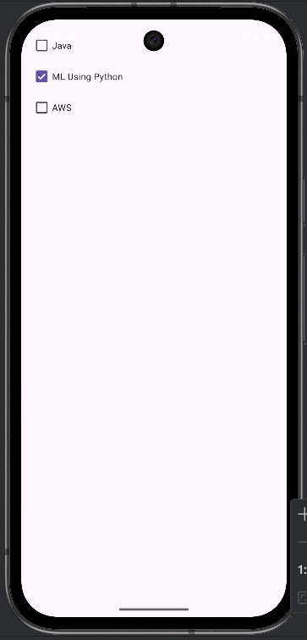

**Toggle Button:** It means to switch between two states, like turning something on or off.

**10. Develop an Android Application using “Toggle Button” Component:**

**Project Name: ToggleButtonExample**

**activity_main.xml:**

<?xml version="1.0" encoding="utf-8"?>

<LinearLayout xmlns:android="http://schemas.android.com/apk/res/android"

android:layout_width="match_parent"

android:layout_height="match_parent"

android:orientation="vertical"

android:padding="16dp">

<!-- First ToggleButton -->

<ToggleButton

android:id="@+id/toggleButton1"

android:layout_width="wrap_content"

android:layout_height="wrap_content"

android:textOn="On"

android:textOff="Off"/>

<!-- Second ToggleButton -->

<ToggleButton

android:id="@+id/toggleButton2"

android:layout_width="wrap_content"

android:layout_height="wrap_content"

android:textOn="Off"

android:textOff="on" />

<!--Third ToggleButton -->

<ToggleButton

android:id="@+id/toggleButton3"

android:layout_width="wrap_content"

android:layout_height="wrap_content"

android:textOn="On"

android:textOff="Off" />

</LinearLayout>

**MainActivity.java:**

package com.example.app10;

import android.os.Bundle;

import androidx.appcompat.app.AppCompatActivity;

public class MainActivity extends AppCompatActivity {

@Override

protected void onCreate(Bundle savedInstanceState) {

super.onCreate(savedInstanceState);

setContentView(R.layout.activity_main);

// No implementation action needed

}

}

**Output:**

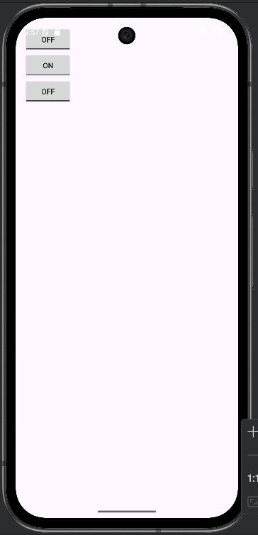

**11. Design an XML layout with a TextView at the top, three EditText fields below it (for Name, Email, and Phone Number), and a Button labeled "Register," all centered vertically on the screen.**

**activity_main.xml:**

<?xml version="1.0" encoding="utf-8"?>  
<LinearLayout xmlns:android="http://schemas.android.com/apk/res/android"  
 android:layout_width="match_parent"  
 android:layout_height="match_parent"  
 android:orientation="vertical"  
 android:gravity="center_horizontal"  
 android:padding="16dp">  
  
 <!-- Heading TextView -->  
 <TextView  
 android:id="@+id/textViewHeading"  
 android:layout_width="wrap_content"  
 android:layout_height="wrap_content"  
 android:text="Registration Form"  
 android:textSize="24sp"  
 android:textStyle="bold"  
 android:layout_marginBottom="24dp" />  
  
 <!-- Name Input -->  
 <EditText  
 android:id="@+id/editTextName"  
 android:layout_width="match_parent"  
 android:layout_height="wrap_content"  
 android:hint="Name"  
 android:inputType="textPersonName"  
 android:layout_marginBottom="12dp" />  
  
 <!-- Email Input -->  
 <EditText  
 android:id="@+id/editTextEmail"  
 android:layout_width="match_parent"  
 android:layout_height="wrap_content"  
 android:hint="Email"  
 android:inputType="textEmailAddress"  
 android:layout_marginBottom="12dp" />  
  
 <!-- Phone Number Input -->  
 <EditText  
 android:id="@+id/editTextPhone"  
 android:layout_width="match_parent"  
 android:layout_height="wrap_content"  
 android:hint="Phone Number"  
 android:inputType="phone"  
 android:layout_marginBottom="20dp" />  
  
 <!-- Register Button -->  
 <Button  
 android:id="@+id/buttonRegister"  
 android:layout_width="match_parent"  
 android:layout_height="wrap_content"  
 android:text="Register" />  
</LinearLayout>

**MainActivity.java:**

package com.example.app11;

import android.os.Bundle;

import androidx.appcompat.app.AppCompatActivity;

public class MainActivity extends AppCompatActivity {

@Override

protected void onCreate(Bundle savedInstanceState) {

super.onCreate(savedInstanceState);

setContentView(R.layout.activity_main); **// Set the content view to the XML layout with the vertical LinearLayout**

}

}

**Output:**

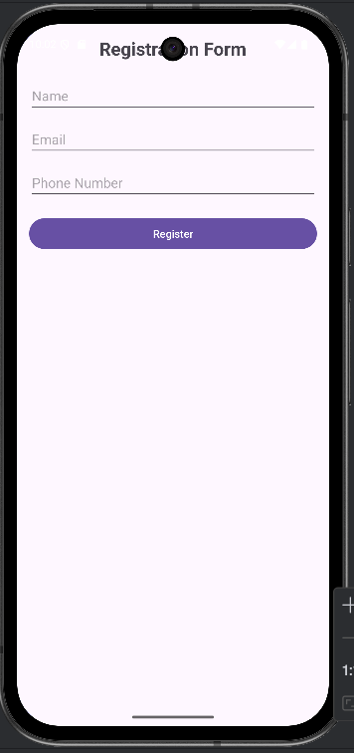

**12. Design an XML layout with an ImageView at the top displaying a logo, followed by two RadioButtons for selecting a "Beginner" or "Advanced" level, and a Button labeled "Start Challenge" at the bottom, all elements centered horizontally.**

**activity_main.xml:**

<?xml version="1.0" encoding="utf-8"?>

<LinearLayout xmlns:android="http://schemas.android.com/apk/res/android"

android:layout_width="match_parent"

android:layout_height="match_parent"

android:orientation="vertical"

android:gravity="center_horizontal"

android:padding="16dp">

<!-- Logo at the top -->

<ImageView

android:id="@+id/imageViewLogo"

android:layout_width="120dp"

android:layout_height="120dp"

android:src="@drawable/ic_logo" <!-- Replace with your logo resource -->

android:contentDescription="App Logo"

android:layout_marginBottom="24dp" />

<!-- RadioButtons for level selection -->

<RadioGroup

android:id="@+id/radioGroupLevels"

android:layout_width="wrap_content"

android:layout_height="wrap_content"

android:orientation="vertical"

android:layout_marginBottom="24dp">

<RadioButton

android:id="@+id/radioBeginner"

android:layout_width="wrap_content"

android:layout_height="wrap_content"

android:text="Beginner"

android:checked="true" />

<RadioButton

android:id="@+id/radioAdvanced"

android:layout_width="wrap_content"

android:layout_height="wrap_content"

android:text="Advanced" />

</RadioGroup>

<!-- Start Challenge button at the bottom -->

<Button

android:id="@+id/buttonStartChallenge"

android:layout_width="wrap_content"

android:layout_height="wrap_content"

android:text="Start Challenge" />

</LinearLayout>

**MainActivity.java:**

package com.example.app12;

import android.os.Bundle;

import androidx.appcompat.app.AppCompatActivity;

public class MainActivity extends AppCompatActivity {

@Override

protected void onCreate(Bundle savedInstanceState) {

super.onCreate(savedInstanceState);

setContentView(R.layout.activity_main); **// Set the content view to the XML layout with the vertical LinearLayout**

}

}

**Output:**

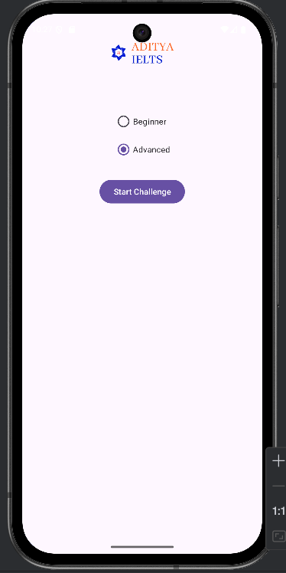

**13. Design an XML layout with a TextView at the top displaying "User Feedback", an EditText field below it for user input, and two Buttons at the bottom labeled "Submit" and "Cancel".**

**activity_main.xml:**

<?xml version="1.0" encoding="utf-8"?>

<RelativeLayout xmlns:android="http://schemas.android.com/apk/res/android"

android:layout_width="match_parent"

android:layout_height="match_parent"

android:padding="16dp">

<!-- Heading at the top -->

<TextView

android:id="@+id/textViewFeedbackTitle"

android:layout_width="wrap_content"

android:layout_height="wrap_content"

android:text="User Feedback"

android:textSize="24sp"

android:textStyle="bold"

android:layout_alignParentTop="true"

android:layout_centerHorizontal="true"

android:layout_marginBottom="16dp" />

<!-- Feedback input field -->

<EditText

android:id="@+id/editTextFeedback"

android:layout_width="match_parent"

android:layout_height="wrap_content"

android:hint="Enter your feedback here"

android:inputType="textMultiLine"

android:minLines="5"

android:gravity="top|start"

android:layout_below="@id/textViewFeedbackTitle"

android:layout_marginTop="16dp" />

<!-- Submit Button at the bottom left -->

<Button

android:id="@+id/buttonSubmit"

android:layout_width="wrap_content"

android:layout_height="wrap_content"

android:text="Submit"

android:layout_alignParentBottom="true"

android:layout_alignParentStart="true"

android:layout_marginEnd="8dp" />

<!-- Cancel Button at the bottom right -->

<Button

android:id="@+id/buttonCancel"

android:layout_width="wrap_content"

android:layout_height="wrap_content"

android:text="Cancel"

android:layout_alignParentBottom="true"

android:layout_alignParentEnd="true" />

</RelativeLayout>

**MainActivity.java:**

package com.example.app13;  
import android.os.Bundle;  
import androidx.appcompat.app.AppCompatActivity;  
public class MainActivity extends AppCompatActivity {  
 @Override  
 protected void onCreate(Bundle savedInstanceState) {  
 super.onCreate(savedInstanceState);  
 setContentView(R.layout.*activity_main*);  
 }  
}

**Output:**

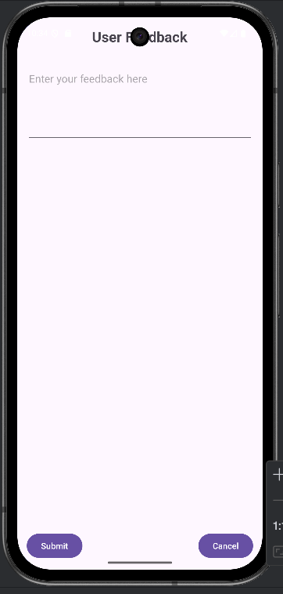

**14. Design an XML layout with a TextView displaying "Profile Setup" at the top, an ImageView for a profile picture placeholder below it, three EditText fields for Name, Email, and Bio, all arranged in a visually appealing manner.**

**activity_main.xml:**

<?xml version="1.0" encoding="utf-8"?>  
<ScrollView xmlns:android="http://schemas.android.com/apk/res/android"  
 android:layout_width="match_parent"  
 android:layout_height="match_parent"  
 android:padding="16dp">  
  
 <LinearLayout  
 android:layout_width="match_parent"  
 android:layout_height="wrap_content"  
 android:orientation="vertical"  
 android:gravity="center_horizontal">  
   
 <TextView  
 android:id="@+id/textViewTitle"  
 android:layout_width="wrap_content"  
 android:layout_height="wrap_content"  
 android:text="Profile Setup"  
 android:textSize="26sp"  
 android:textStyle="bold"  
 android:layout_marginBottom="20dp" />  
   
 <ImageView  
 android:id="@+id/imageViewProfile"  
 android:layout_width="120dp"  
 android:layout_height="120dp"  
 android:src="@drawable/user"  
 android:contentDescription="Profile Picture"  
 android:scaleType="centerCrop"  
 android:layout_marginBottom="20dp" />  
   
 <EditText  
 android:id="@+id/editTextName"  
 android:layout_width="match_parent"  
 android:layout_height="wrap_content"  
 android:hint="Name"  
 android:inputType="textPersonName"  
 android:layout_marginBottom="12dp" />  
   
 <EditText  
 android:id="@+id/editTextEmail"  
 android:layout_width="match_parent"  
 android:layout_height="wrap_content"  
 android:hint="Email"  
 android:inputType="textEmailAddress"  
 android:layout_marginBottom="12dp" />  
   
 <EditText  
 android:id="@+id/editTextBio"  
 android:layout_width="match_parent"  
 android:layout_height="wrap_content"  
 android:hint="Bio"  
 android:inputType="textMultiLine"  
 android:minLines="3"  
 android:gravity="top|start"  
 android:layout_marginBottom="20dp" />  
   
 <LinearLayout  
 android:layout_width="match_parent"  
 android:layout_height="wrap_content"  
 android:orientation="horizontal"  
 android:gravity="center"  
 android:layout_marginTop="10dp">  
  
 <Button  
 android:id="@+id/buttonSubmit"  
 android:layout_width="wrap_content"  
 android:layout_height="wrap_content"  
 android:text="Submit"  
 android:layout_marginEnd="20dp" />  
  
 <Button  
 android:id="@+id/buttonCancel"  
 android:layout_width="wrap_content"  
 android:layout_height="wrap_content"  
 android:text="Cancel" />  
 </LinearLayout>  
  
 </LinearLayout>  
</ScrollView>

**MainActivity.java:**

package com.example.app14;  
import android.os.Bundle;  
import androidx.appcompat.app.AppCompatActivity;  
public class MainActivity extends AppCompatActivity {  
 @Override  
 protected void onCreate(Bundle savedInstanceState) {  
 super.onCreate(savedInstanceState);  
 setContentView(R.layout.*activity_main*);  
 }  
}

**Output:**

